**Progress Report**

**On**

**Resume Builder**

**Subject Code: 3IT31**

**(Mini Project)**

**Academic Year 2023-24**

|  |  |
| --- | --- |
| **Name of Students** | **: Prince Moradiya (21IT412)** |
|  | **Jay Butani (21IT407)** |
| **Batch** | **: A 10 A** |
| **Guide Name** | **: Prof. Vishal Polara** |
|  |  |

**BACHELOR OF ENGINEERING**

**In**

**INFORMATION TECHNOLOGY**



**Birla Vishwakarma Mahavidhyalaya Engineering College,**

**Vallabh Vidhyanagar-388120**

**Date: Signature**

**Table of Contents**

1. Project Definition: 3

2. Project Objective: 3

3. Project Scope: 3

4. Project Modules: 3

5. Project Basic Requirements: 3

5.1. Hardware requirements: 3

5.2. Software requirements: 3

6. Literature Review: 4

7. Project Feasibility Study: 5

7.1. Technical Feasibility: 5

7.2. Operational Feasibility: 5

7.3. Economic Feasibility: 6

7.4. Legal and Ethical Feasibility: 6

7.5. Schedule Feasibility: 6

7.6. Risk Analysis: 6

8. Project Requirement Gathering 6

8.1. Requirement Gathering Techniques for your project. 6

8.2. Comparison of Existing Applications with your Application 9

9. Project Timeline chart 10

10. Project work distribution among team members 11

**Attendance Management System Using Face Recognition**

1. **Project Definition**

* Our project aims to develop an Automated Attendance System using state-of-the-art technologies. The system leverages liveness face detection and recognition techniques, incorporating the Haar Cascade Classifier for face detection and the FaceNet Convolutional Neural Network (CNN) algorithm for face recognition. To enhance user accessibility, the system will be integrated into a Flutter-based application, providing a seamless and user-friendly experience.

1. **Project Objective:**

* To automate the attendance tracking process.
* To enhance accuracy and efficiency in attendance management.
* To streamline the overall attendance process, enabling quick and timely generation of attendance reports.
* To minimize administrative workload by automating repetitive tasks associated with attendance monitoring.

1. **Project Scope:**

* The project primarily focuses on automating the attendance taking process for companies or organizations are used for attendance taking using face recognition technology.
* The system will be designed to capture attendance once a day, streamlining the process to improve efficiency and accuracy.
* **Target Audience:** The target audience for the system is educational institutions and offices that want to enhance their attendance management process.

1. **Project Module:**
   * 1. **Registration and Login:**

* To use various features of the app or the app the user has to register him/herself.
* Once the user registers then the user will be asked to login in order to use the functionality of the app.
* Only the logged in user can use all the features of the app.
  + 1. **Face Detection and Recognition Module:**
* Once the user gets logged in, the mobile camera will detect the face of the user and recognize it from the model.
* This module will provide the feature of face detection and attendance marking.
  + 1. **Attendance Traking Module:**
* This module contains a monthly calendar where the user can track his/her attendance or can have a glimpse of the monthly attendance.
  + 1. **User-Friendly Interface:**
* Designing an intuitive and user-friendly interface for system administrators and end-users.
* Incorporating features for easy system configuration and management.
  + 1. **Notification System:**
* It provides notifications related to holidays, low attendance etc.
  + 1. **Attendance Report:**
* Generating automated attendance reports with customizable parameters.

1. **Project basic requirements:**
   * 1. **Hardware:**
   * Mobile Device
   * Server
     1. **Software:**

* Programming Languages: Dart, Node Js, Python.
* Framework: Flutter
* Server and Hosting: Render

1. **Literature Review:**

**6.1** A real time automated attendance system is designed using the

method of live face detection and recognition. The system

supports multi-user attendance and **face liveness detection** at

the same time. The system can automatically collect face data,

that will be saved in the specified dataset folder of each

individual person obtained during the registration process. The

face detection part of the system is based on **Haar Cascade**

**Classifier**, and the face recognition part is based on **Local**

**Binary Pattern Histogram** algorithm. The algorithm

implementation is based on **Keras** and **TensorFlow** framework,

and the face liveness detection part is based on **CNN** that

creates a 3D model of face detected to differentiate between real

and fake images. The attendance system is written in Python

language, and the user interface is designed by pywebview

library. The experimental results show that the system achieves

a good performance in real-time face recognition.

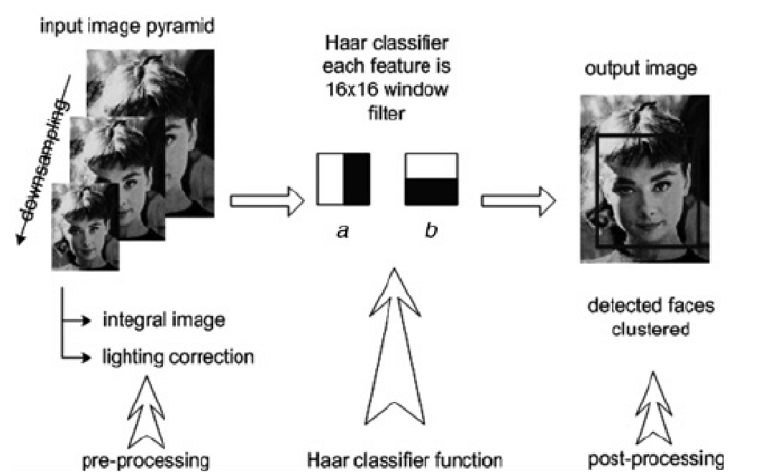

**Fig1: Face Detection using Haar Cascade Classifier**

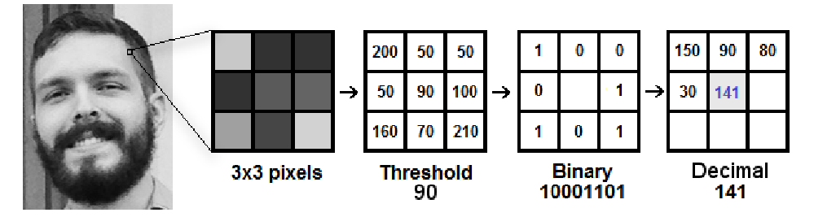

**Fig2: Pixel Matrix to Binary Pattern using LBPH**

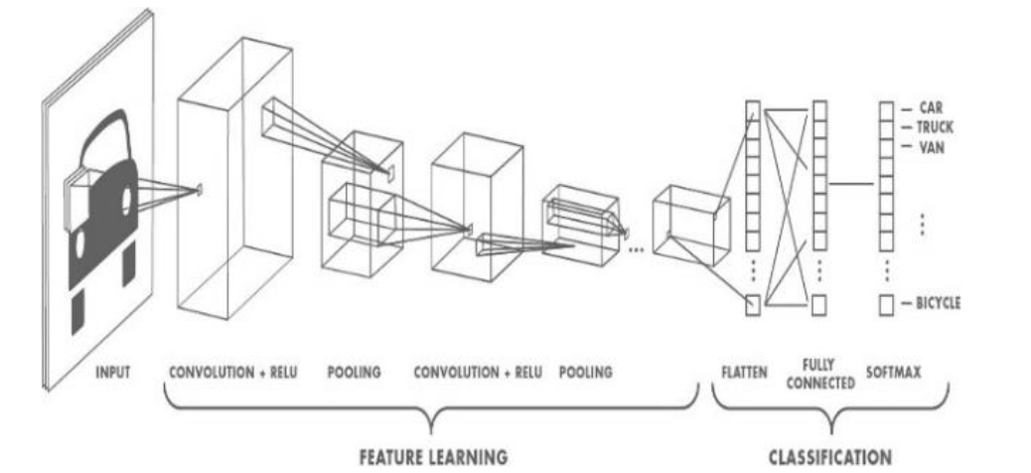

**Fig3: Working of CNN**

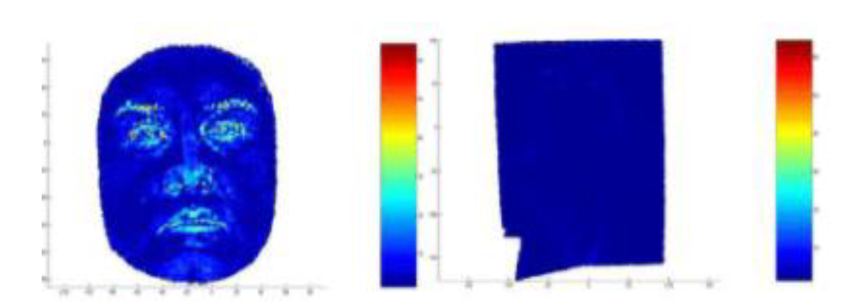

**Fig4: Real Face (3D) vs. Spoofed Face (2D)**

**6.2** 2017 **Samuel John** presented a Face Recognition Attendance System with GSM Notification. This system uses the **Viola-Jones** algorithm. This algorithm used for detect faces. Also, **Fisher faces** algorithm was used to create patterns of the faces which were caught. That created templates stored in the database. This system used library which is **OpenCV** and used Software **Development Kit (SDK)** to create the graphical user interface.

**6.3** other paper, **Jenif D Souza** introduces a Automated Attendance Marking and Management System by Facial Recognition. This system marked students attendance automatically by the camera which captures the photo of student in the class. This system uses the algorithm called **Histogram.** Histogram algorithm used for face identification purpose. In this algorithm, The face image is converted to matrix form. Histogram are used for recognize of the exact faces.

This system overcome the problem of time consuming.

**6.4** 2019 **Nandhini R**. introduced Attendance System based on face recognition. This system capture the video of the students, convert it into frames and store it in the database. Also, **Convolution Neural Network(CNN)** algorithm is used to detect faces. This System helps in improving the **accuracy** and **speed.**

**6.5** 2019 **Shreyak Sawhney**, **karan kicker**, **Samyakjain** introduced Real Time Smart Attendance Management System Using Face Recognition Techniques. In this system they use face detection and recognition method using **convolution Neural Network** and **Principal Component Analysis (PCA)** but using two camera some camera is used for the face detection and recognition at the door of classroom and the camera is used at inside the classroom for checking proxy attendance.

**6.6** 2016 **E Vardharajan**, **R Dharani**, **S Jeevitha**, **S Hemalata** introduced Automatic Attendance Management System Using Face Recognition. In this system the use **Eigen Faces**, **Eigen Weight** method for face detection this system the camera detention the image and then system crop the faces of student and tie the faces with student database.

1. **Project feasibility study:**
2. **Technical Feasibility:**
   * **Liveness Face Recognition Technology:** Evaluate the availability and effectiveness of liveness detection techniques within face recognition libraries.
   * **Flutter Development:** Assess Flutter's capabilities for integrating with liveness face recognition libraries and building user-friendly mobile applications.
   * **Integration:** Check the compatibility of liveness face recognition technology with mobile platforms and databases.
3. **Operational Feasibility:**
   * **User Acceptance:** Gauge the acceptance of users toward a mobile application with liveness face recognition for attendance.
   * **Training Needs:** Assess the training requirements for users and administrators to use the liveness face recognition system and the Flutter application.
   * **Operational Impact:** Evaluate how the new system will fit into existing operational workflows and any changes required.
4. **Economic Feasibility:**
   * **Cost Analysis:** Estimate the costs associated with liveness face recognition technology, Flutter development, training, and maintenance.
   * **Return on Investment (ROI):** Evaluate potential benefits, including improved security and accuracy, compared to the costs.
5. **Legal and Ethical Feasibility:**
   * **Privacy Regulations:** Ensure compliance with data protection laws and regulations related to biometric data and facial recognition.
   * **Consent and Transparency:** Address ethical considerations by implementing clear consent processes and ensuring transparency in data usage.
6. **Schedule Feasibility:**
   * **Development Time:** Assess the time required for developing both the liveness face recognition system and the Flutter application.
   * **Testing and Deployment:** Plan for sufficient testing phases, especially for liveness detection, and deployment schedules considering any dependencies.

**7.6 Risk Analysis:**

* **Liveness Detection Risks:** Identify potential challenges and risks associated with liveness detection accuracy and develop mitigation strategies.
* **User Adoption Risks:** Consider potential user resistance to liveness face recognition technology.

1. **Project Requirement Gathering:**

**8.1 Techniques for Requirement Gathering:**

1. **User Stories and Scenarios:**
   * Develop user stories to capture the needs of different user roles (e.g., administrators, students).
   * Create scenarios to understand how users will interact with the system in various situations.
2. **Liveness Detection Requirements:**
   * Specifically focus on liveness detection requirements.
   * Understand the desired level of security and accuracy in detecting live faces to prevent fraudulent attempts.
3. **Prototyping with Liveness Detection:**
   * Develop prototypes or mockups that include elements of the liveness detection feature.
   * Gather feedback on the visual representation and functionality of liveness detection.
4. **Surveys for User Preferences:**
   * Distribute surveys to potential end-users to understand their preferences regarding mobile applications and liveness detection.
   * Gather feedback on the desired user experience.
5. **Requirement Workshops for Flutter Application:**
   * Host workshops specifically for Flutter application requirements.
   * Discuss features, UI/UX preferences, and integration requirements.

**8.2 Comparison of Existing Applications:**

1. **Accuracy:**

* **Existing System:**
  + Accuracy might be dependent on traditional methods like card swiping or manual entry.
  + Prone to issues like buddy punching (one person clocking in for another).
  + Limited ability to prevent attendance fraud.
* **Proposed System with Liveness Face Recognition:**
  + Higher accuracy due to liveness detection, preventing the use of static images or videos.
  + Reduced chances of fraudulent attendance, enhancing overall system reliability.

1. **Security:**

* **Existing System:**
  + Relies on physical credentials (cards, badges) that can be lost, stolen, or shared.
  + Limited security measures to prevent unauthorized access.
* **Proposed System with Liveness Face Recognition:**
  + Enhances security through biometric authentication.
  + Liveness detection adds an extra layer of protection against spoofing attacks.

1. **Usability:**

* **Existing System:**
  + Users may find traditional methods cumbersome and time-consuming.
  + Manual data entry may lead to errors and inefficiencies.
* **Proposed System with Liveness Face Recognition:**
  + Improved user experience with a quick and automated attendance process.
  + Streamlined workflow and reduced administrative burden.

1. **Cost:**

* **Existing System:**
  + Costs associated with physical cards, badges, and potential replacements.
  + Ongoing expenses for maintenance and support.
* **Proposed System with Liveness Face Recognition:**
  + Initial setup costs for face recognition technology and Flutter application development.
  + Potential long-term cost savings due to reduced reliance on physical credentials.

1. **Project Timeline chart (Till 25/01/24):**

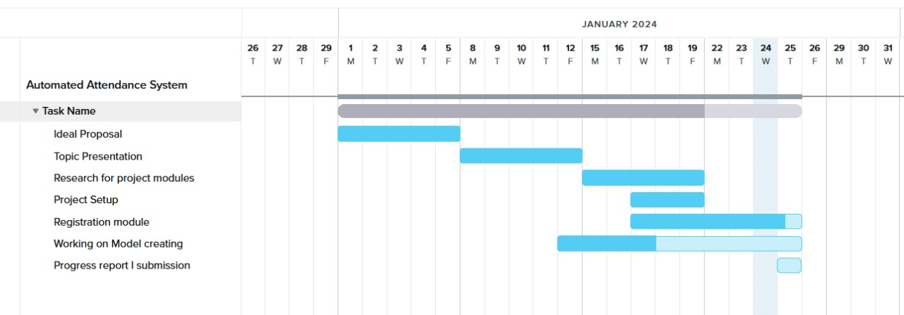

**(Figure 9.1)**

1. **Project work distribution among team members**

* **Frontend:** will be developed by PRINCE MORADIYA
* **ML models:** will be developed by JAY BUTANI
* **Backend:** Equally divided among us